**PROJECT REPORT TEMPLATE**

**TEAM ID-NM2023TMID17468**

**1. INTRODUCTION**

**1.1 OVERVIEW**

Event management as a career is a multifaceted activity. It involves management, creation, and development of events such as corporate conferences, wedding , festivities formal paties etc.

**1.2 Purpose**

It involves a lot of research about the brand, target audience and the concept of the event before planning the actual event.

**2. Problem Definition & Design Thinking**

2.1 Empathy Map

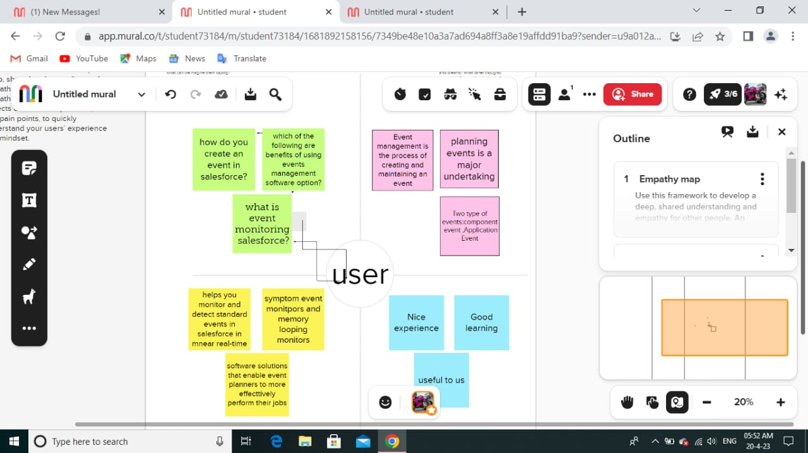

2.2 Ideation & brainstorming

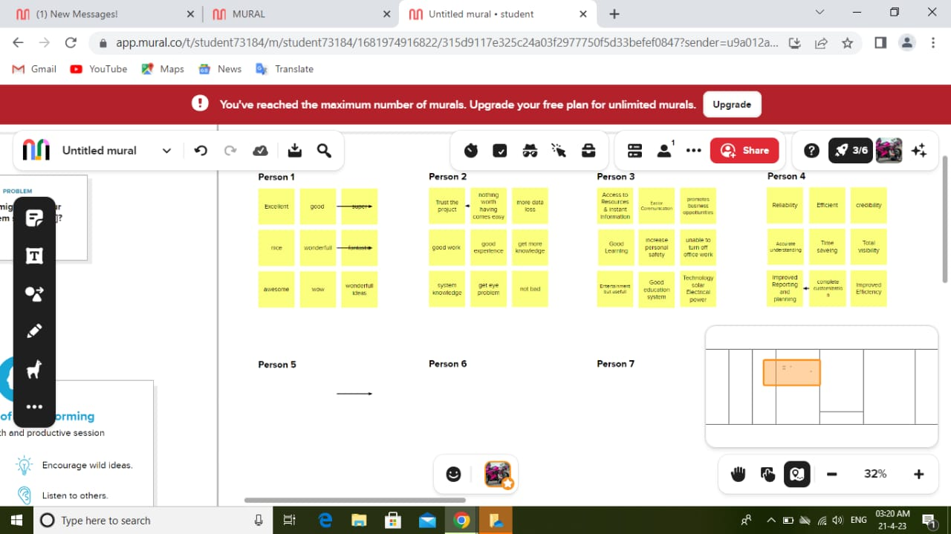

**3. RESULT**

**3.1 Data Model**

|  |  |
| --- | --- |
| Object name | Fields in the Object |
| Events | |  |  | | --- | --- | | Fields lable | Data type | | City  Start Date | Text  Date/time | |
| Attendees | |  |  | | --- | --- | | Field lable | Data type | | Id  Phone  Email  Tickets | Auto number  Phone  Emil  Picklist | |
| Speakers | |  |  | | --- | --- | | Field lable | Data type | | Bio  E-mail  Event name | Text area  Email  Look-up relationship | |
| Vendors | |  |  | | --- | --- | | Field lable | Data type | | E-mail  Phone  Service Provider | Email  Phone  Text | |

**3.2 Activity & Screenshot**

**Activity 1:**

Creation of Object for Event Management:

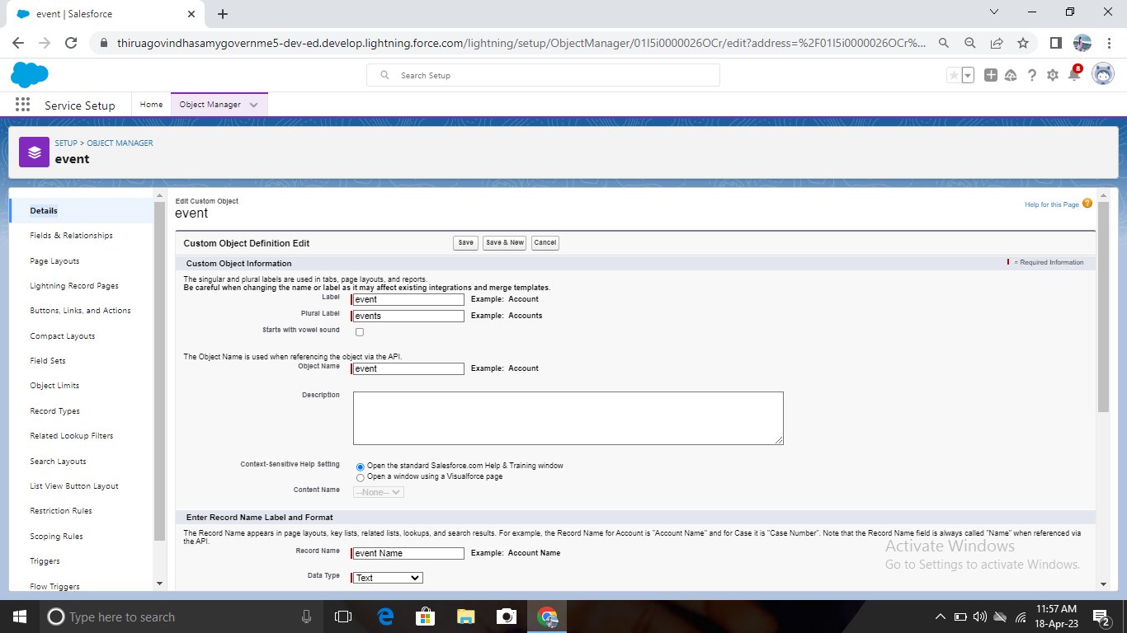

**Activity 2:**

Creation of the Attendees Object:

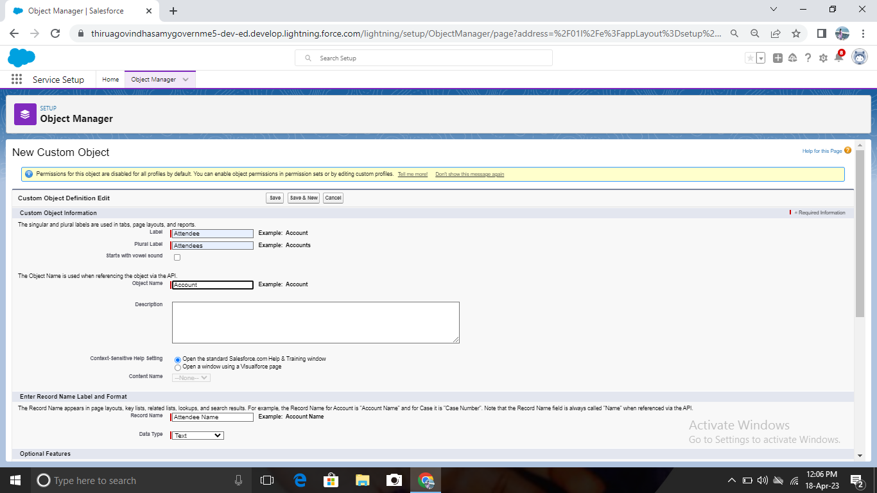

**Activity 3:**

Creation of the Speaker Object:

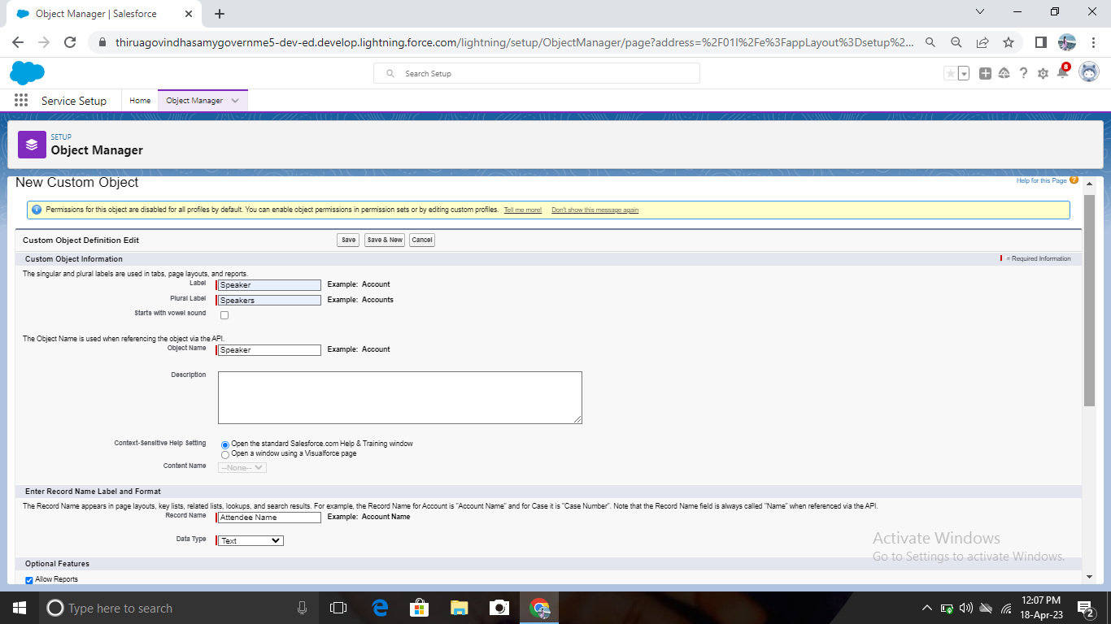

**Activity 4:**

Creation of the Vendors Object:

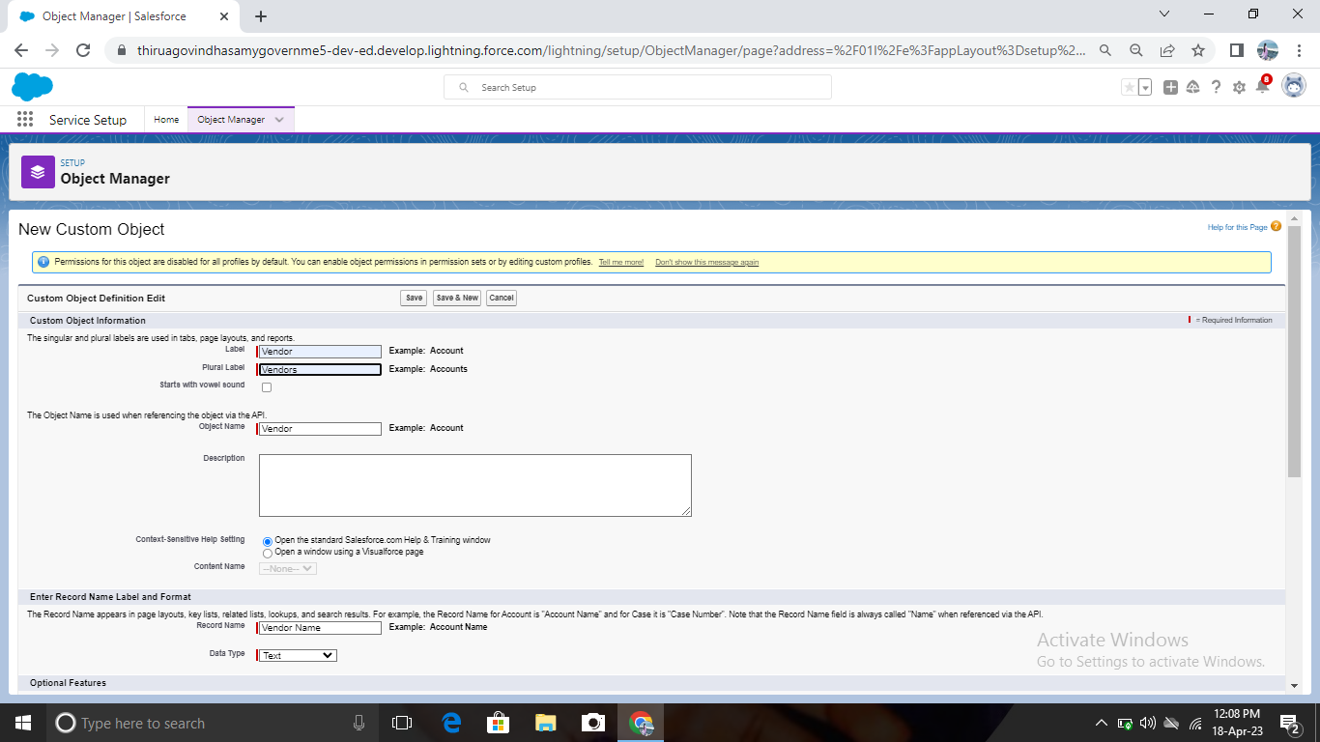

**Tabs**

Creation of Tabs:

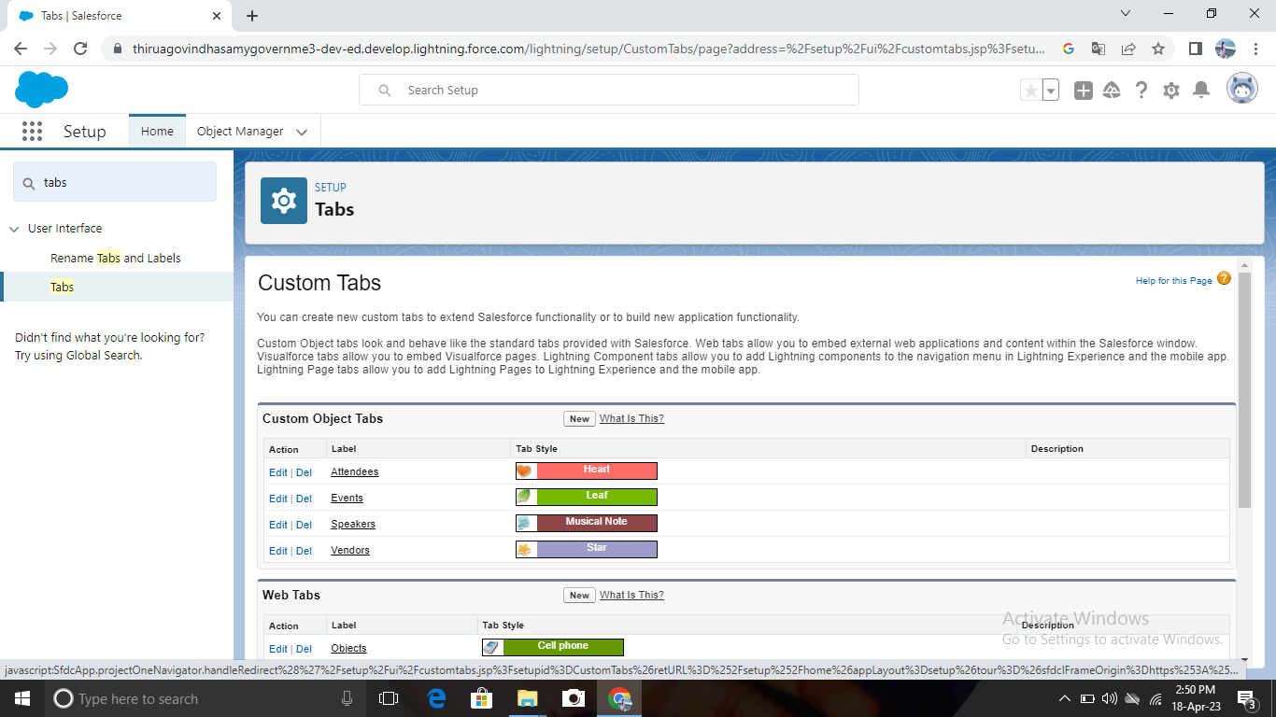

**Application**

Create the Event Management Construction app:

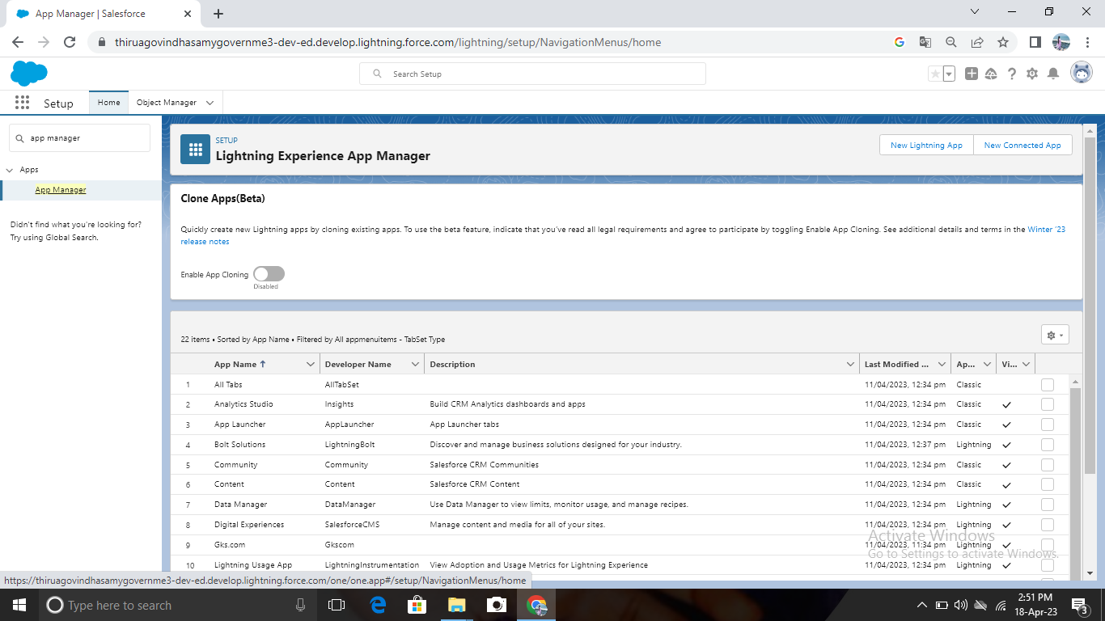

**Fields**

Creation of fields:

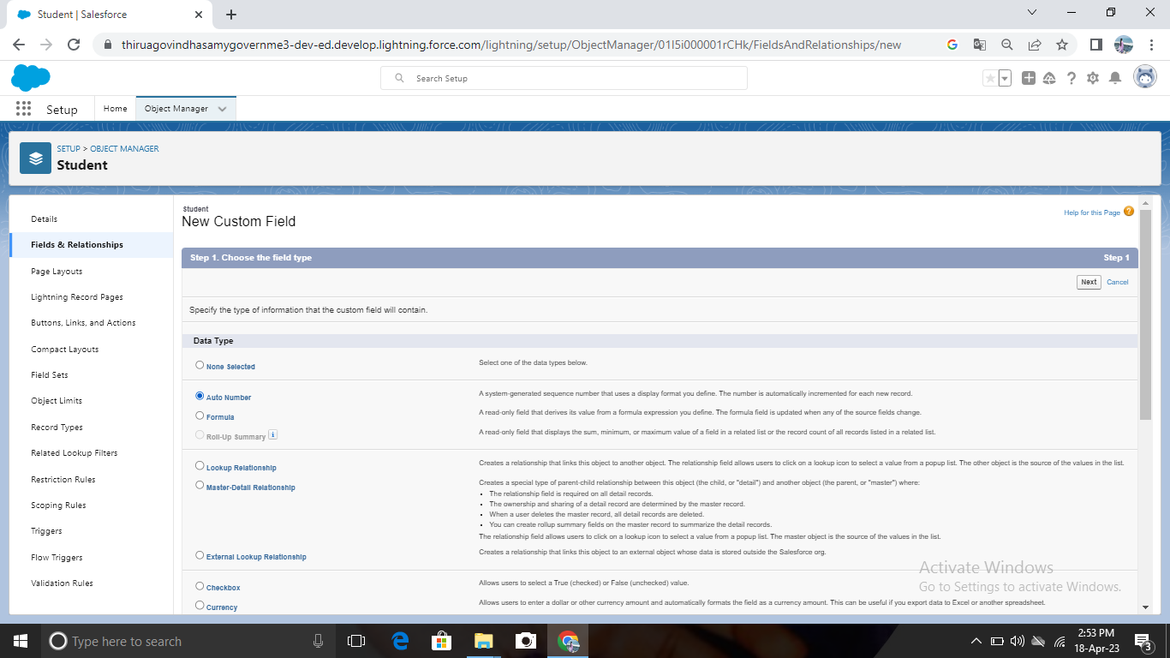

**Profile**

Creation of profile:

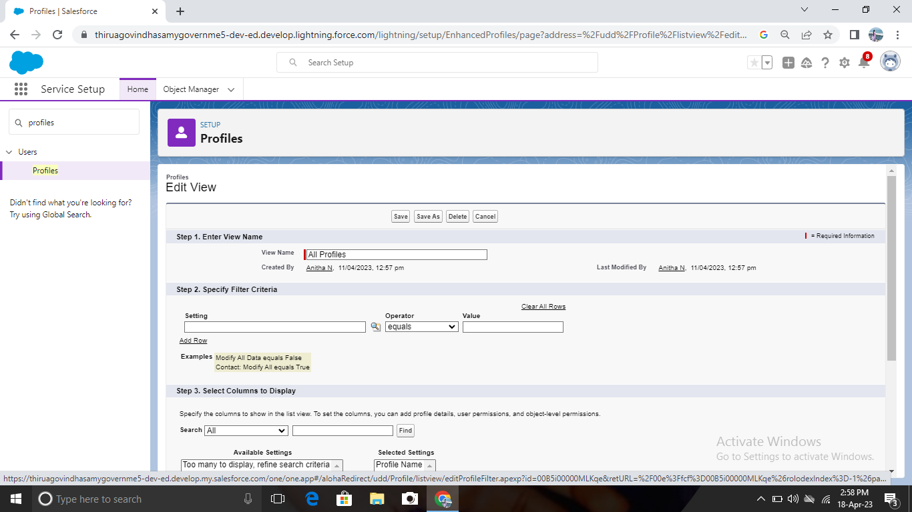

**User**

Creating a user:

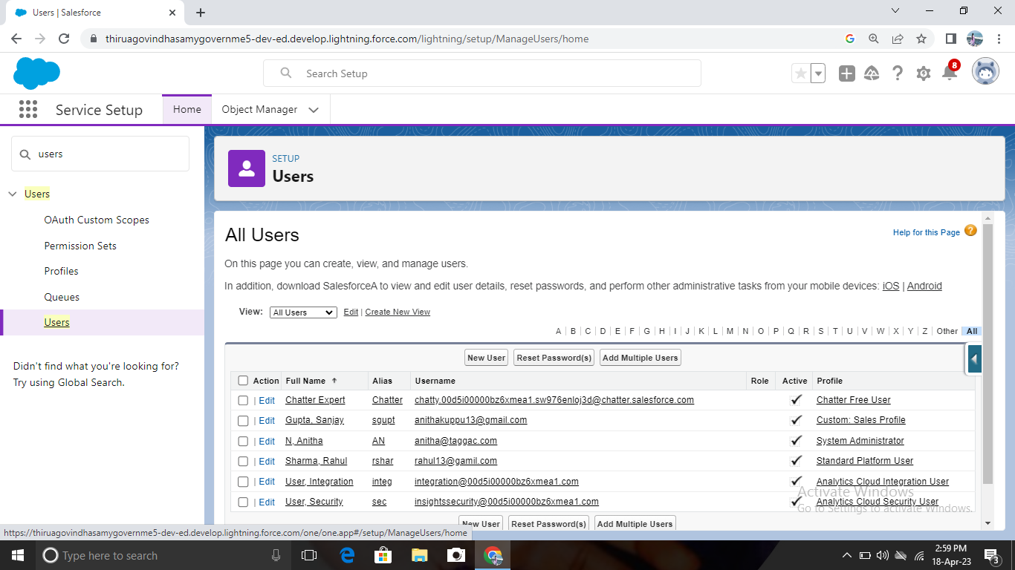

**Permission Sets**

Creating a Permission Sets:

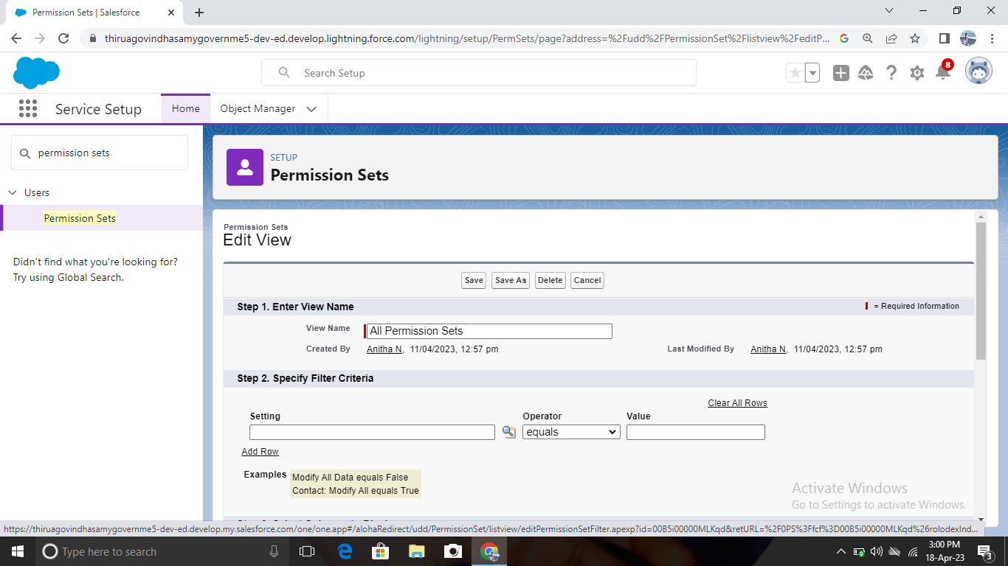

**Reports**

Creating a Report:

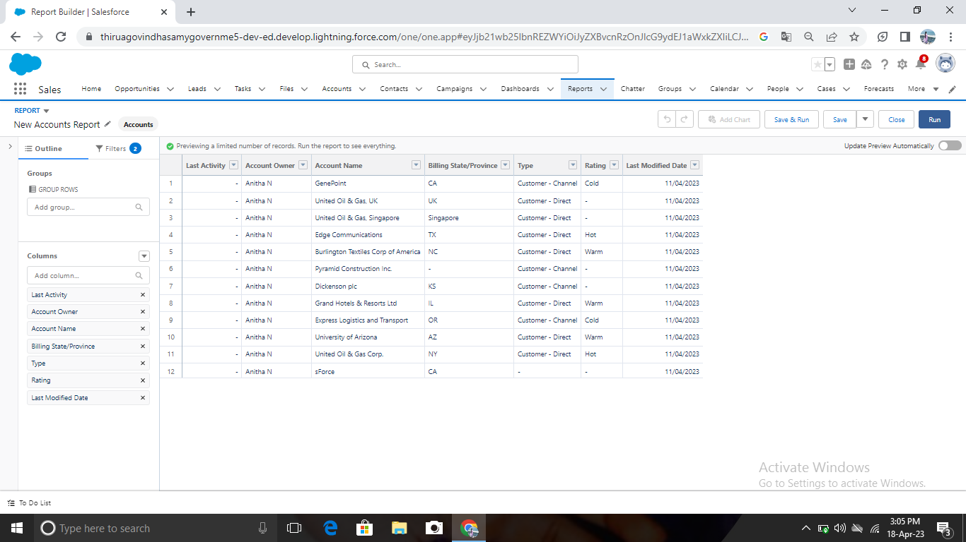

**4. Trailhead Profile Public URL**

Team Lead-https://trailblazer.me/id/aanitha34

Team Member 1-https://trailblazer.me/id/rindumathi1

Team Member 2-https://trailblazer.me/id/jeevs26

Team Member 3-https://trailblazer.me/id/kshalini9

**5. ADVANTAGES & DISADVANTAGE**

Advantages: Gives you creative ideas

Ability to work on different events

Time away from family and friends.

Disadvantage : Difficult to handle work manually

Time consuming process

More human power required.

**6. APPLICATION**

These apps come with every occurrence of Salesforce as default. Community Call Centre Content, Sales, Marketing, Salesforce chatter, Site.com and App Launcher.

**7. CONCLUSION**

Event Management system is user friendly and cost effective system, it is customized with activities related to event management life-cycle. It provides a new edge to management industry. SolutionDot always keep your objects and goals on top priority while developing any plan of work.

**8. FUTURE SCOPE**

The Scope of event management as career in India is vast. It’s thriving industry and is home to a million people. So , if you have a knack for creativity and want to redesign the perception of society, the event management industry is for all.